**SIMPLE STEPS TO TAKE BACK UP OF PDPX FROM XDESIGN**

Open the Document in xDesign and Click Tools and Options from Tools menu

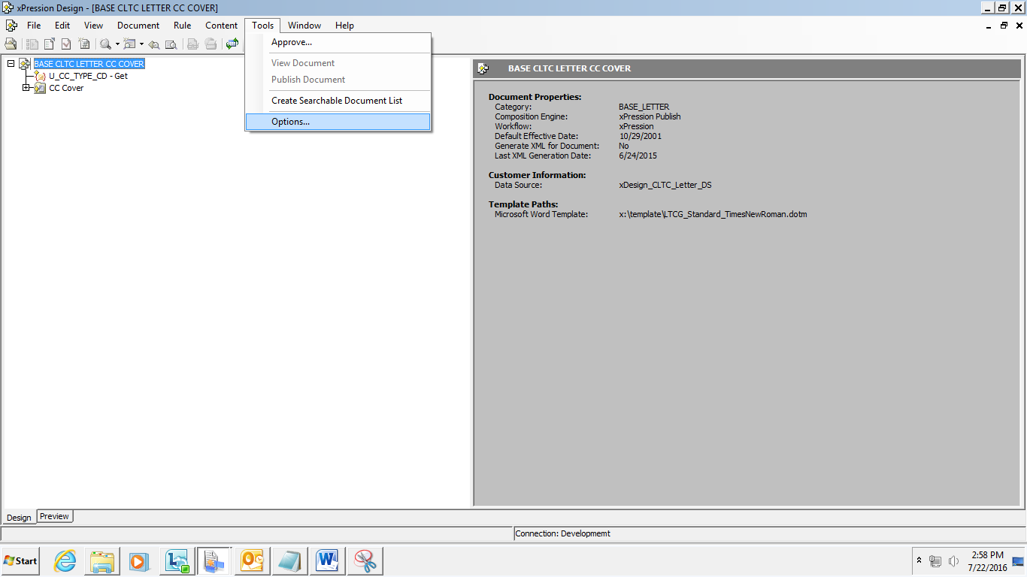

Go to the Diagnostic Information Collector Tab and then To add components to the list, click **Add**, choose the document's category from the list, and then select the document.

The document's entry in the list includes the document name, a PDPX check box, a Template check box, the Data Source Group name, and the Data Source. The Data Source field is a list that enables you to select the data source, but only XML files are listed. You can select single or multiple documents and it can be included in the Documents List

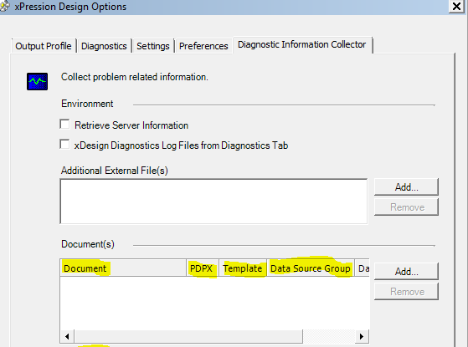

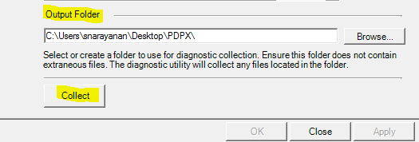

**Output Folder**

Files from Document list are collected to the document folder under the target “output folder”.

Specify the target output folder here. You can either type the path, or click **Browse** and navigate to the desired output folder

Ensure that the output folder is empty before collecting diagnostic information to prevent inclusion of obsolete or irrelevant information in the package to be analyzed.

**Collect**

Click this button to proceed with the collection. Ensure that all necessary files have been identified on the Diagnostics tab. All files are written to the output folder and archived to a ZIP file. In addition a summary file, SupportUtilityReport.doc, is produced and included in the collection.

These files can records OS environment, xDesign version, and selection information. A message displays the location and filename of the package as shown below.

